# Name: Virtual Assistant

# Project Description:

This project is to provide an assistance in facing new equipment in the industry. Through this project, they can obtain complete information regarding the device or equipment. Only thing they have to do is, giving its name or serial no or its image as input. This device will check for it in the databases and gives us resulted information.

# Project Pre-requisites:

1. MySQL Server
2. LABVIEW SQL toolkit

# Execution procedure:

**Connecting to Database:**

Follow the below steps to connect to database.

1. If you don’t have sql server in your computer. Please Download and install MySQL Server from the following link :

https://www.microsoft.com/en-in/download/details.aspx?id=42299

1. After installation restore the database from the zipped folder named “PRODUCT.bak” by following the below method.
2. Create a database with the name “PRODUCT”. Select the database.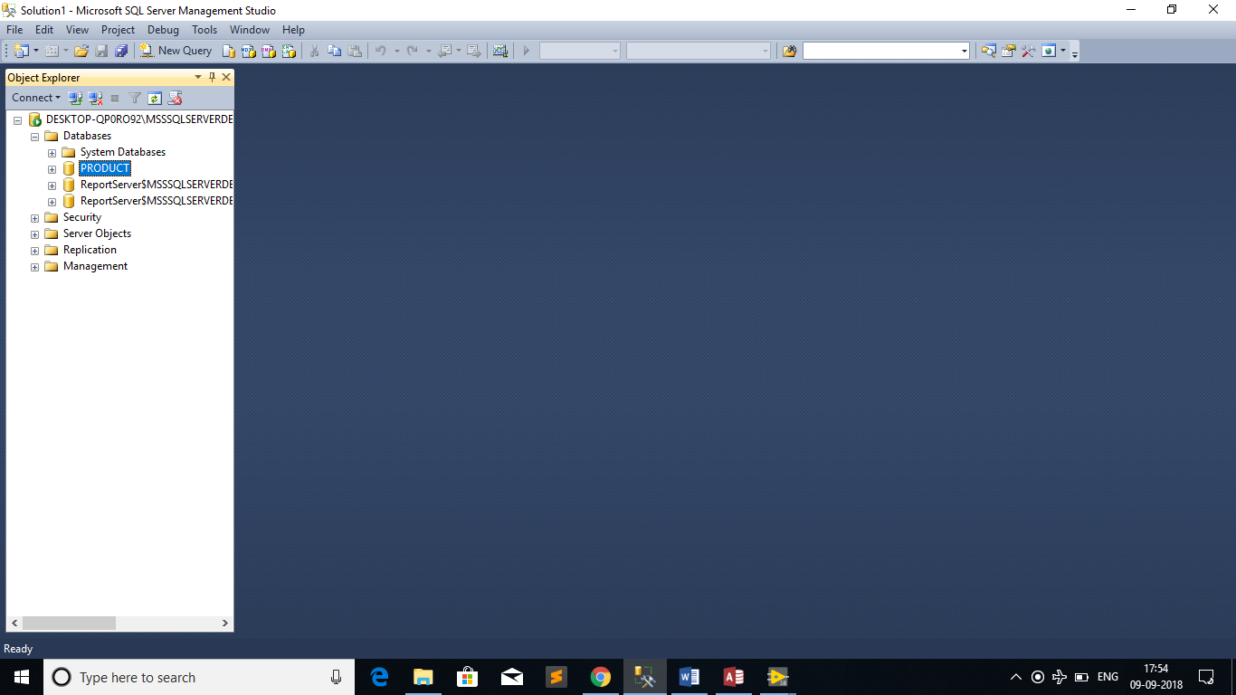
3. Right click on the database name >> Tasks >> Restore >> Database.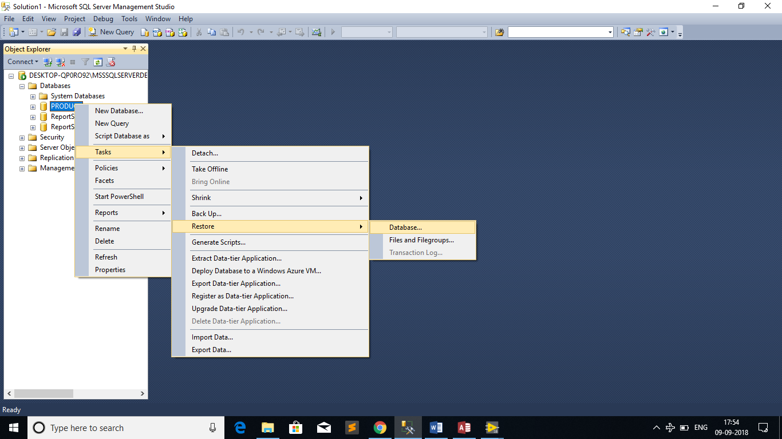
4. Select “Device” as source. Select Destination >> Add

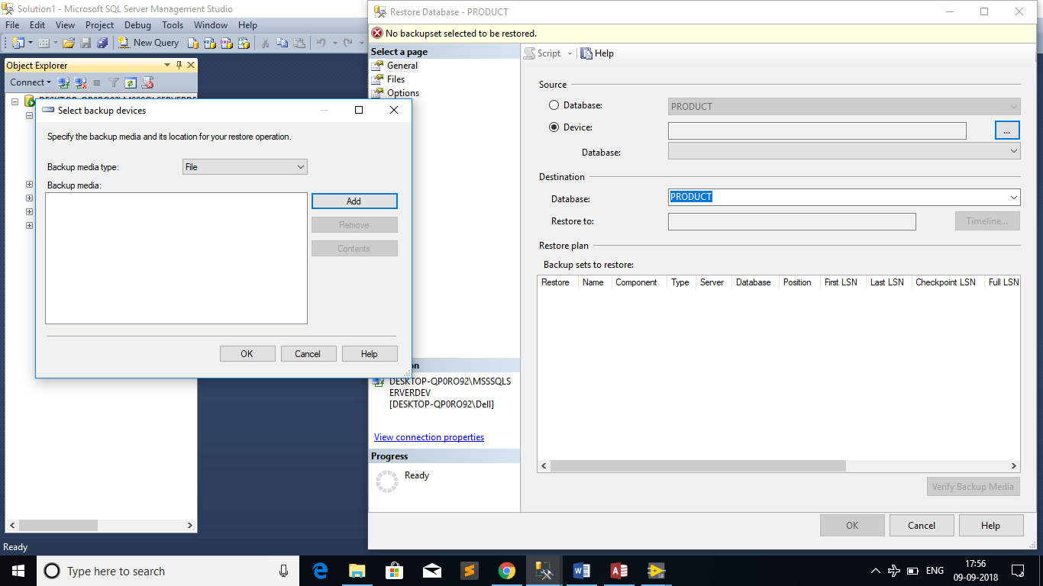

1. Select the file named PRODUCT.bak from the received zip folder. Click “OK”.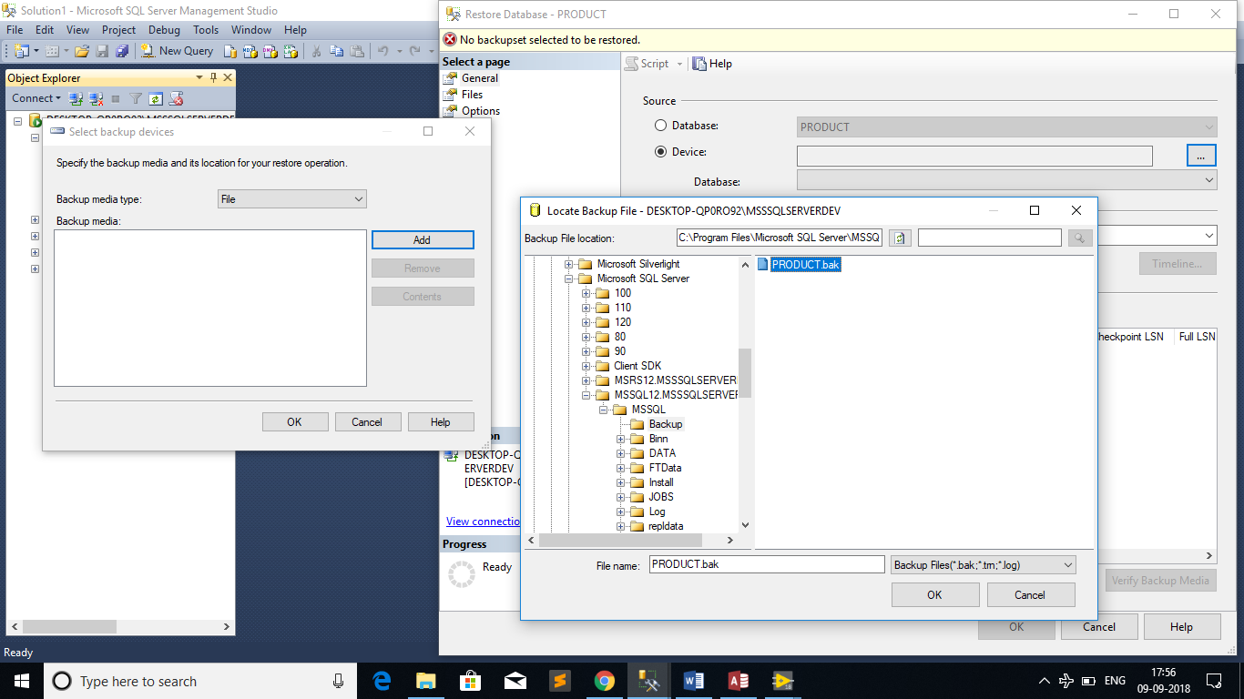
2. Click “OK”. Database will be backed up.
3. 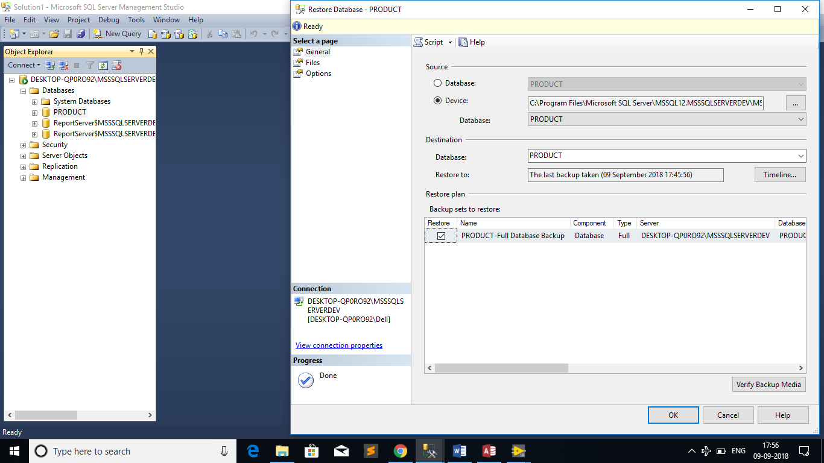
4. Now enable ODBC connection for the database using the below steps:
5. Please go to this path Control panel 🡪Administration Tools 🡪 Data Sources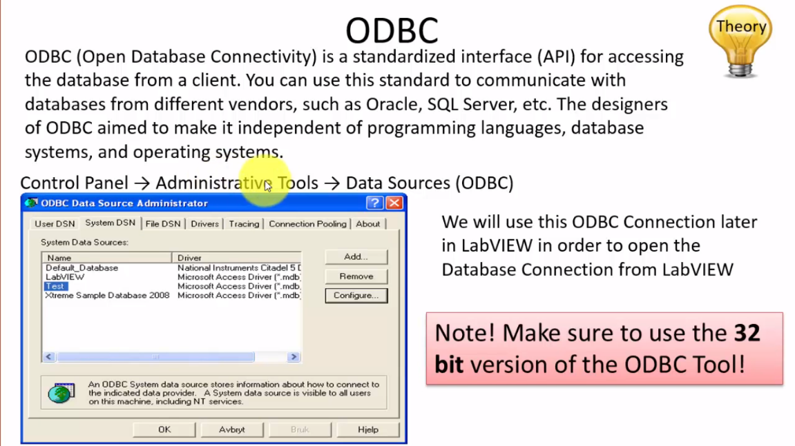
6. Follow the steps shown in images as highlighted

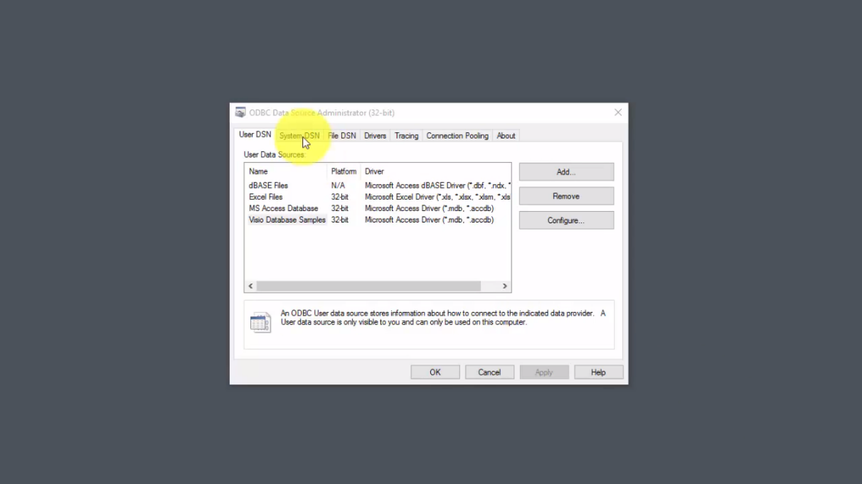

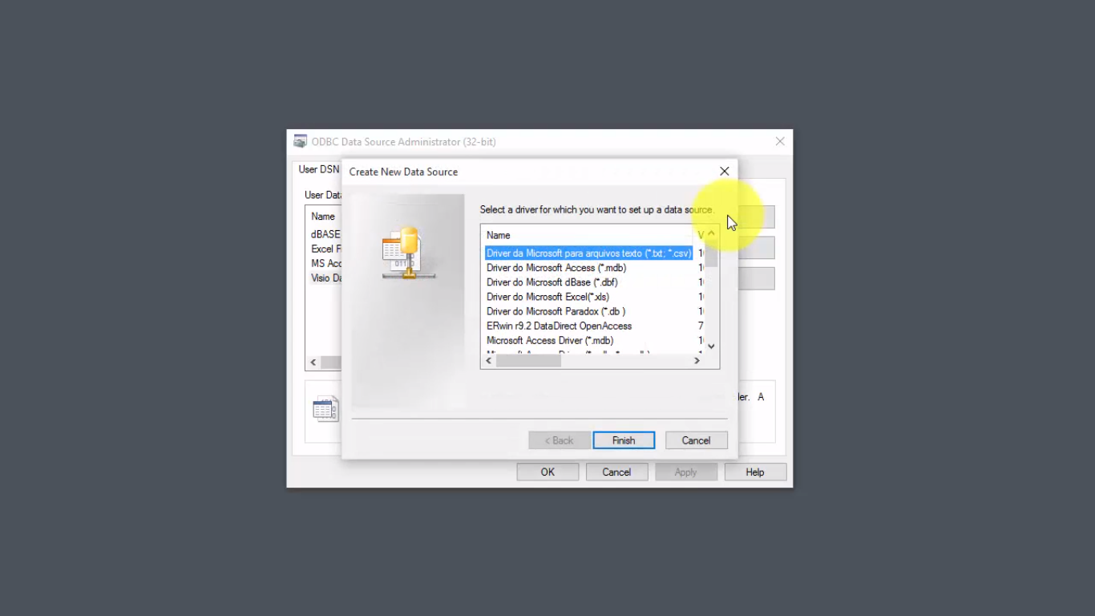

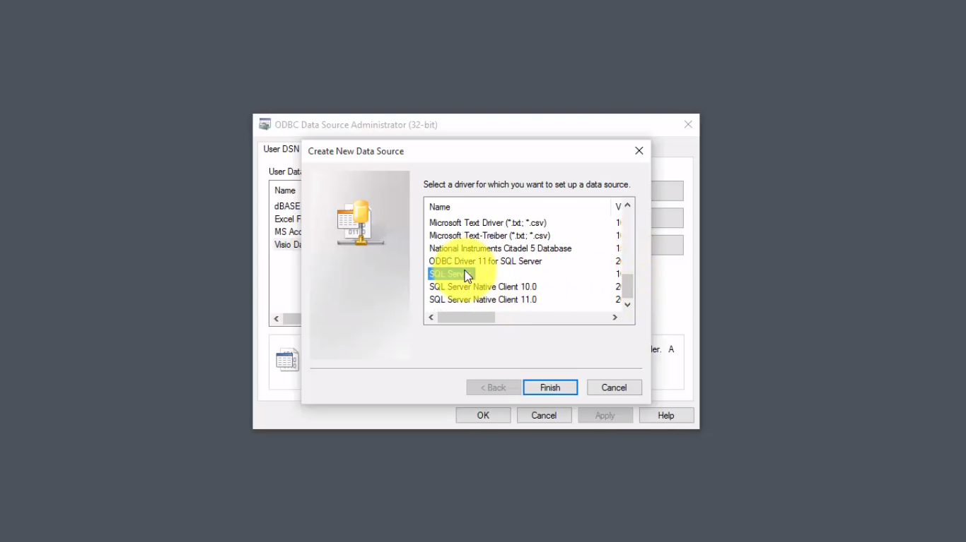

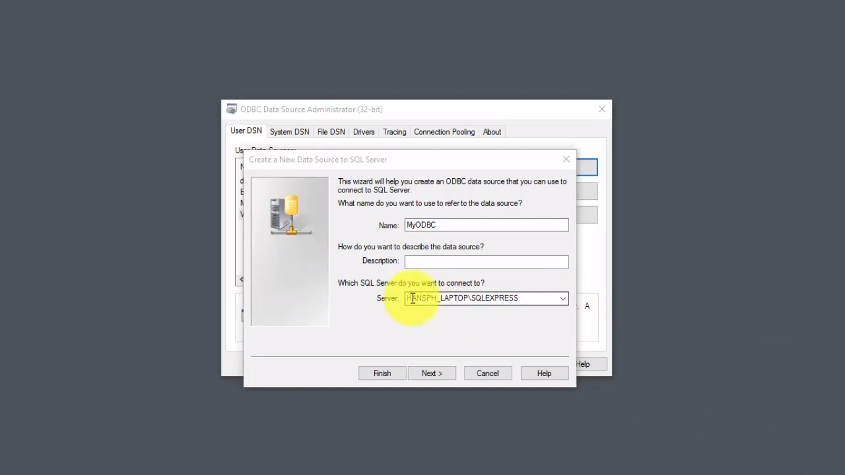

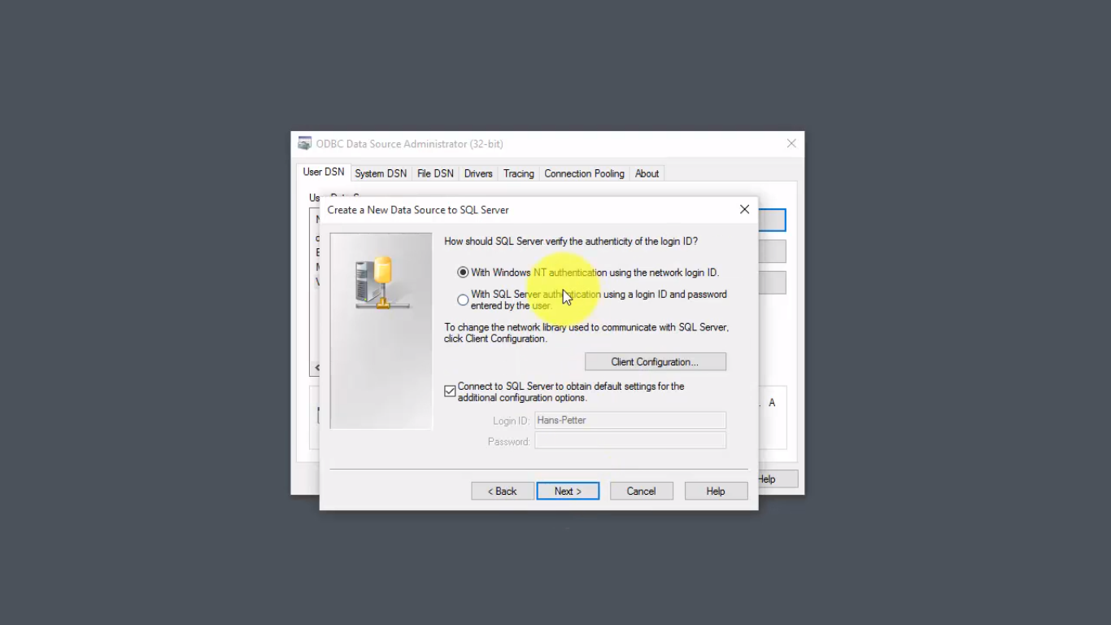

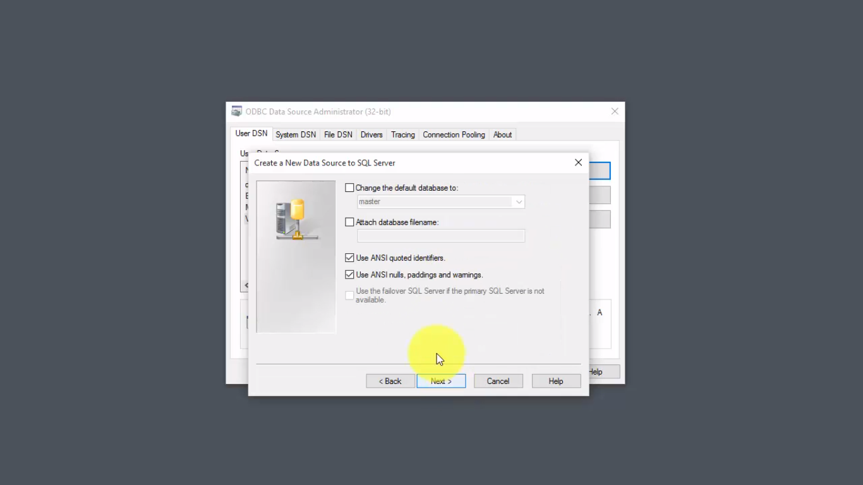

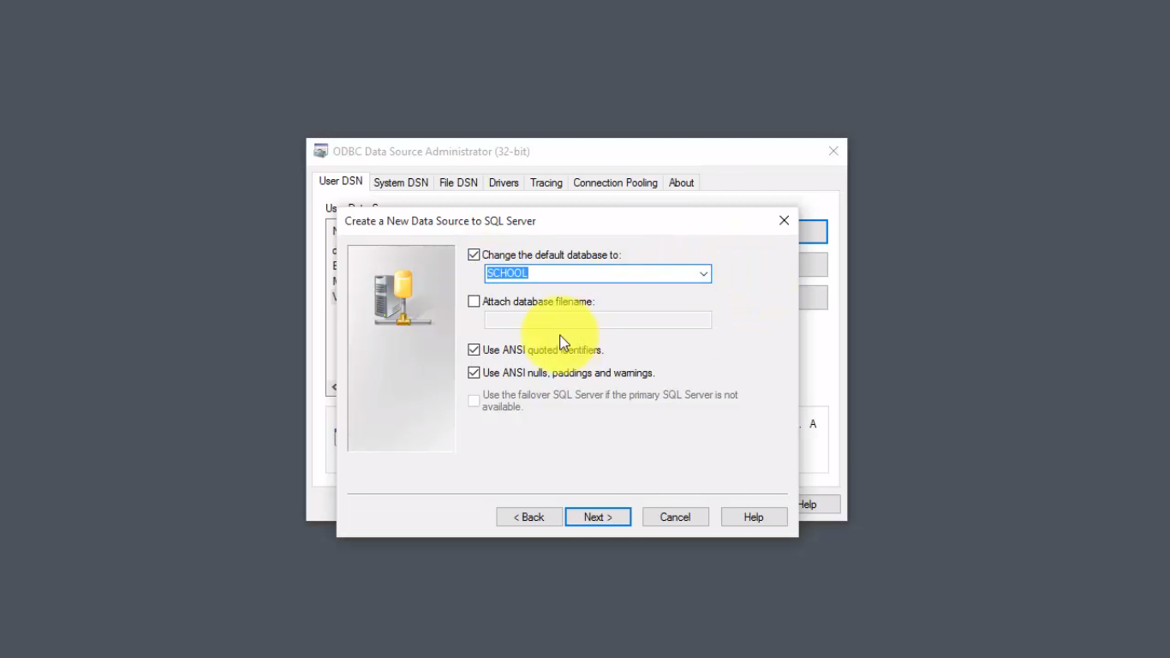

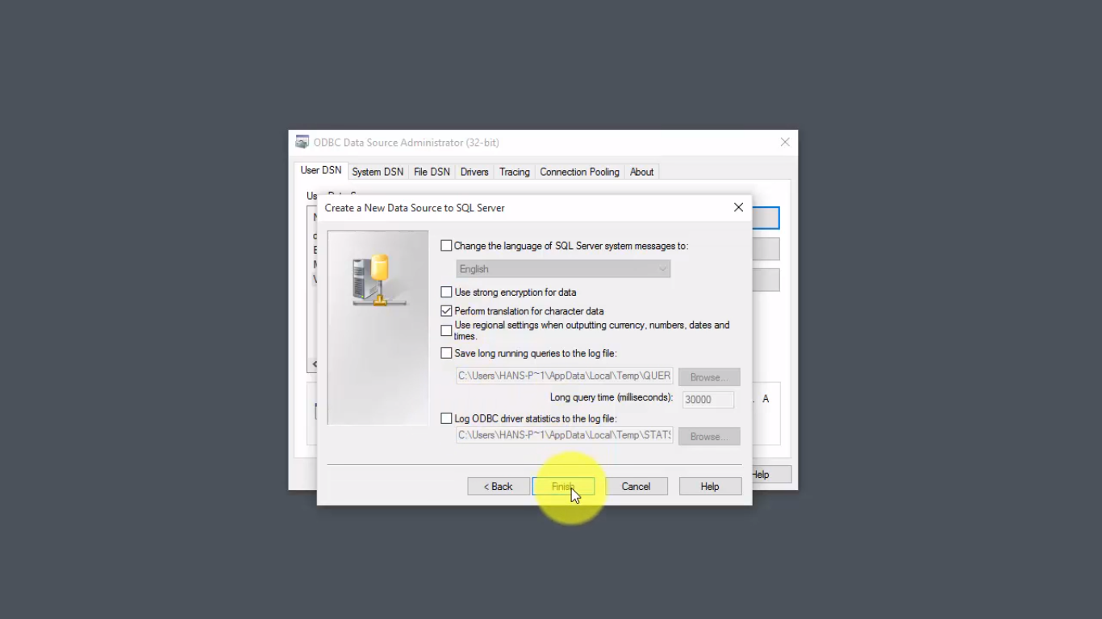

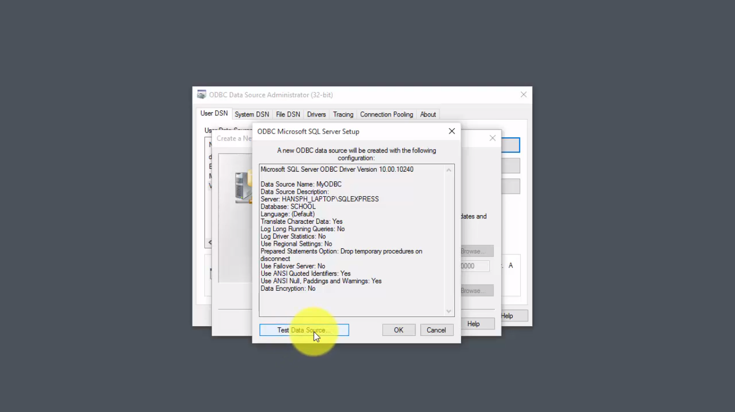

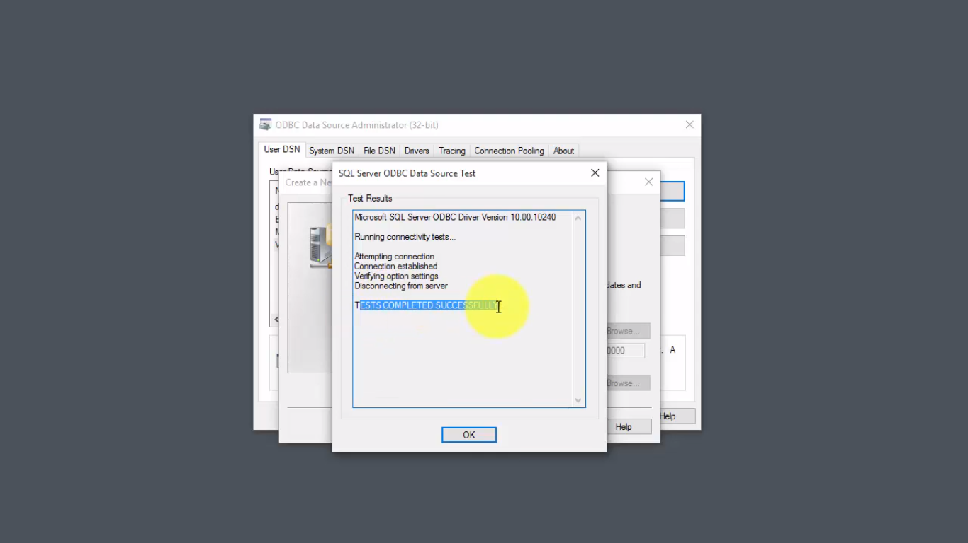

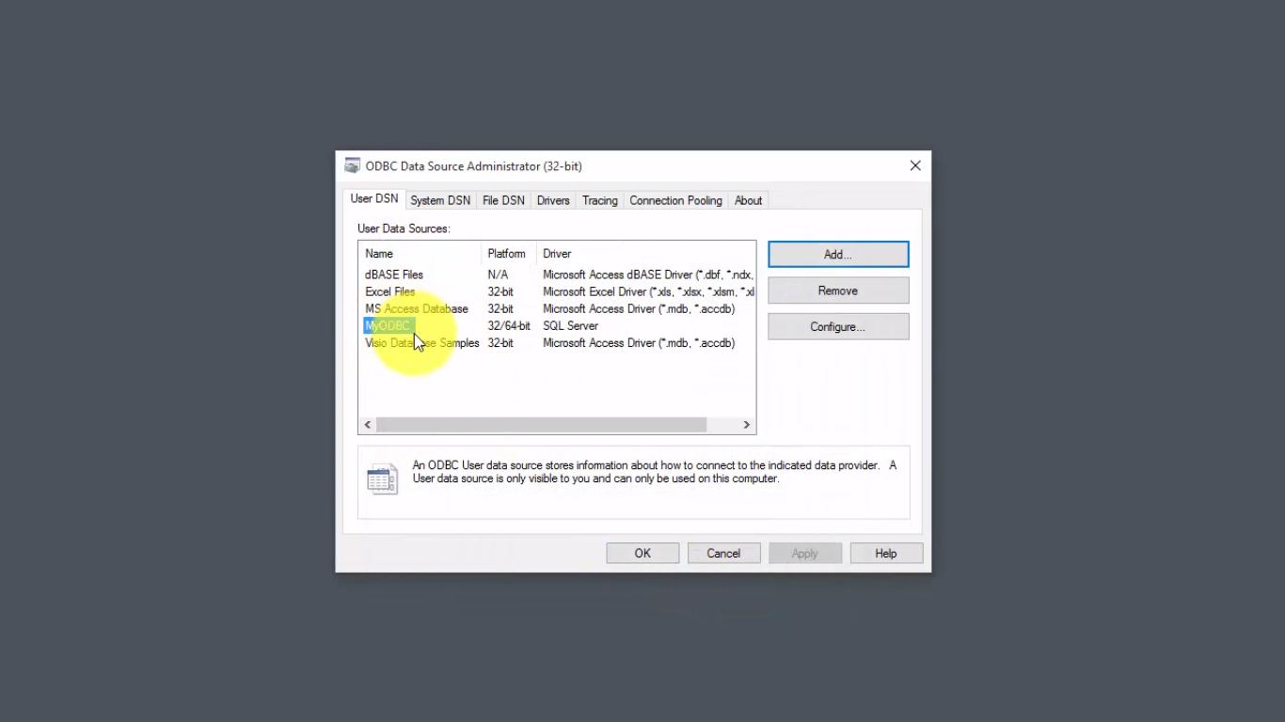

**NOTE: Here I have created the ODBC connection with name MyODBC. You can use any name. but use need use the same name in our simulation.**

4) Sql Toolkits has to be added to our functional palatte.

I’m attaching Required files in the folder. In order to simulate my project, this has to be present in function palette. Please

Copy "SQLToolkit.mnu" to

C:\Program Files (x86)\National Instruments\LabVIEW 2018\menus\Categories

Copy "SQLToolkit.llb" to

C:\Program Files (x86)\National Instruments\LabVIEW 2018\vi.lib\

In the Functions palette in LabVIEW a new palette named "SQL" will appear.

The SQL Toolkit contains the following Main VIs:

"SQL Open.vi" ->This VI open a connection to the Database specified in the Connection string

"SQL Select.vi" ->This VI get data from the database specified in the SQL Query

"SQL Execute.vi"->This VI executes a Query with no return Data, e.g., an INSERT statement

"SQL Close.vi" ->This VI Close the connection to the Database opened by "SQL Open.vi"